Deploy Project using ECR
Stage 01
- Go to AWS Console and open: ECR
- Make sure ur region its must be important when we create EC2 instance
- Now create ECR for ur project
- Create 2 ECR repo for backend and frontend
- After creating, you will see something like:
- 123456789.dkr.ecr.ap-south-1.amazonaws.com/backend
- 123456789.dkr.ecr.ap-south-1.amazonaws.com/frontend
- U have to save this in notepad (optional) but if not u can see it after going ECR on AWS

Stage 02
- You only need to do 2 things here
- Create IAM User → for Jenkins (push to ECR)
- Create IAM Role → for EC2 (pull from ECR)
- Create IAM user for Jenkins
- Go to AWS → IAM
- Click “Users” → “Create user” - jenkins-ecr-user
- Set permissions - Select: Attach policies directly
- Select AmazonEC2ContainerRegistryFullAccess
- Next → Create user
- Now Create Access key
- After user created Go inside the user and Click Security credentials and Scroll → Access keys → Create key
- Choose: Command Line Interface (CLI)
- Copy these IDs – IMPORTANT (COPY THIS CREDENTIALS INTO NOTEPAD)
- Access Key ID
- Secret Access Key
- Create IAM Roles for Jenkins
- Go to “Roles” → Create role
- Select: AWS service and EC2
- Attach permission
- Select AmazonEC2ContainerRegistryFullAccess
- Name the role EC2-ECR-Role

Stage 03
- Now create EC2 instance
- Now let’s attach to ROLE into EC2
- Go to: EC2 → your instance
- Actions → Security → Modify IAM role
- Select: EC2-ECR-Role

Stage 04
- Go to Jenkins and install this plugin AWS Credentials
- After install go to credentials in Jenkins select AWS credentials
- Username = AWS Access Key ID – {IAM user credentials}
- Password = AWS Secret Access Key
- ID = aws-creds (u can change anything to it)
- Go to terminal and run docker –version u must see version (if not install docker)
- Also run aws --version
- If not install go to this link and download after install it https://awscli.amazonaws.com/AWSCLIV2.msi
- And then go to CLI file path (usually C:\Program Files\Amazon\AWSCLIV2)
- Now go to environment variable in the and set environment variable after choose path click new and add that file path after click all windows OK button)
- Now check terminal (CMD) aws –version
- Configure Aws in Jenkins User Context
- Open CMD and run: aws configure
- AWS Access Key ID → your IAM key
AWS Secret Access Key → your IAM secret
Region → us-east-1
Output format → json
- Now test: aws sts get-caller-identity

Stage 05
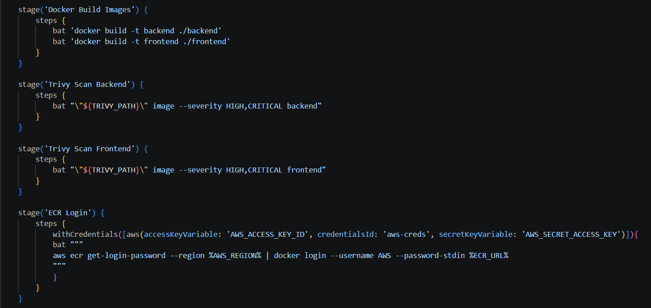
- Create Jenkins file
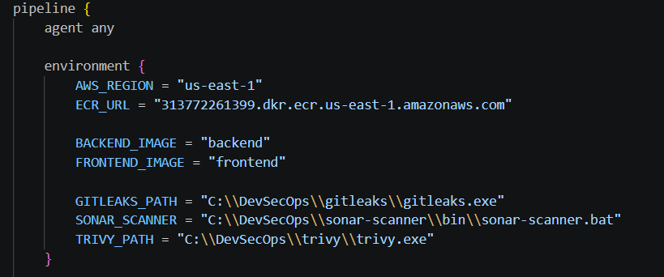
- Add like this environment top of code (adjust ur region and ECR URL)

- then build docker image (images name same as top of code) and scan each images also then login ECR (IMPORTANT)
- Set credential using pipelines syntax (use aws credential) after u can connect ur ECR
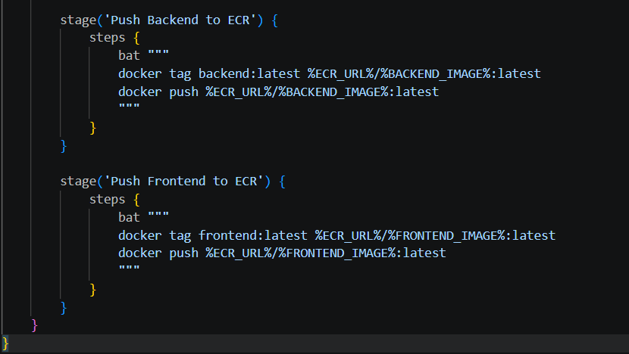
- To connect ECR use this aws ecr get-login-password --region <Your Region> | docker login --username AWS --password-stdin <ECR_URL>

- Now we can push our images into ECR
- Note: Before push images make sure ur images optimized (if not ur images become huge size (1GB+)

Stage 06
- Install Docker and awscli in EC2
- Go to EC2 server using ssh
- sudo apt update
- sudo apt install docker.io -y
- Then start Docker:
- sudo systemctl start docker
- sudo systemctl enable docker
- docker –version
- Next Check — Aws Cli
- Type aws –version (If version not found)
- curl "https://awscli.amazonaws.com/awscli-exe-linux-x86_64.zip" -o "awscliv2.zip"
- sudo apt update
- check using ls if file is exit
- install unzip package sudo apt install unzip -y
- type unzip awscliv2.zip
- Now sudo ./aws/install
- Now check aws –version
- Install docker compose
- sudo apt update
- sudo apt install ca-certificates curl gnupg lsb-release -y
- sudo install -m 0755 -d /etc/apt/keyrings
- curl -fsSL https://download.docker.com/linux/ubuntu/gpg | \
sudo gpg --dearmor -o /etc/apt/keyrings/docker.gpg
- echo \
"deb [arch=$(dpkg --print-architecture) signed-by=/etc/apt/keyrings/docker.gpg] \
https://download.docker.com/linux/ubuntu $(lsb_release -cs) stable" | \
sudo tee /etc/apt/sources.list.d/docker.list > /dev/null
- sudo apt update
- sudo apt install docker-ce docker-ce-cli containerd.io docker-buildx-plugin docker-compose-plugin -y
- docker compose version
- Then check docker compose version docker compose version

Stage 07
- Now Install git on EC2 sudo apt install git -y
- Clone the repo git clone <repo URL>
- Go to ur folder cd <ur folder name>
- Edit docker compose file nano docker-compose.yml (or u can edited on locllay after push images into ECR)
- Now Login To ECR (Very Important)
- aws ecr get-login-password --region <ur region>| docker login --username AWS --password-stdin <ECR URL>
- Must show: Login Succeeded

Optional
- Sometime docker services are stop so then u have to start docker service
sudo systemctl start docker
- Now Enable Docker on boot sudo systemctl enable docker
- Or u can restart docker sudo systemctl restart docker
- Check status sudo systemctl status docker
- Check using docker ps
- Then u can login ECR again

- Now u can pull images docker compose pull
- Now up container docker compose up -d
- U can check ECR repos using aws ecr describe-repositories --region us-east-1

